**Nordic Minimalist Geometric Stag Head**

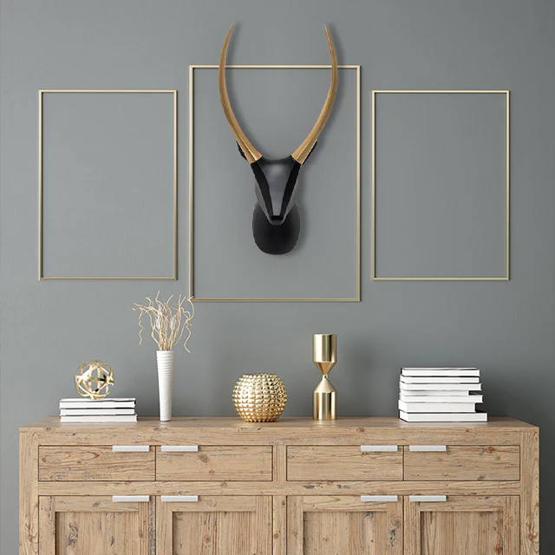A Nordic minimalist geometric stag head is a chic and contemporary decor piece that blends the elegance of Scandinavian design with the boldness of geometric art. Crafted with clean, angular lines, this 3D representation of a stag head captures the essence of nature in a modern, abstract form. Typically made from materials like metal, wood, or resin and finished in neutral or metallic tones such as white, black, or gold, it seamlessly fits into modern, Nordic, or minimalist interiors. Mounted on a wall in a living room, hallway, or study, this striking piece adds sophistication, harmony, and a touch of nature-inspired artistry to any space.